HTML Noscript Element

📘 Definition
# Source: AI Source: Provided by: [Data Path: Persons Table -> ID Column: 1, Name_En Column: Motasem Essam] -> From: [ChatGPT] on [5/6/2026]
The <noscript> element is used to display alternative content when:
- JavaScript is disabled
- Or the browser does not support JavaScript
It provides a fallback message or content for users without JavaScript.

⚙️ How <noscript> works
# Source: AI Source: Provided by: [Data Path: Persons Table -> ID Column: 1, Name_En Column: Motasem Essam] -> From: [ChatGPT] on [5/6/2026]
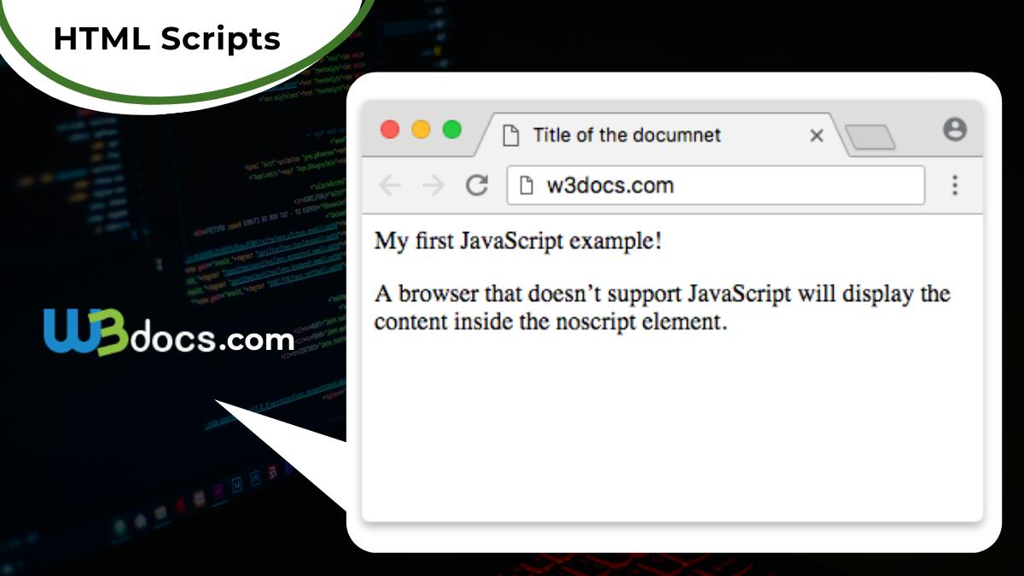
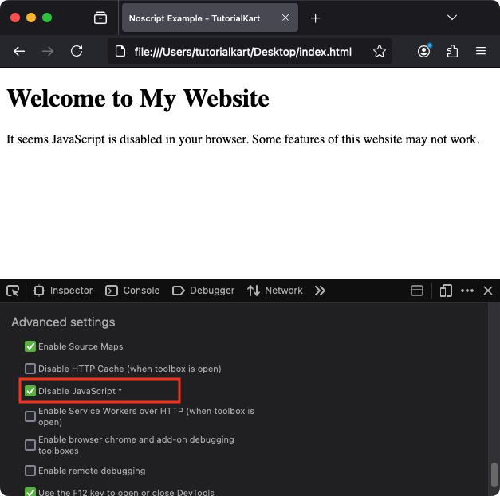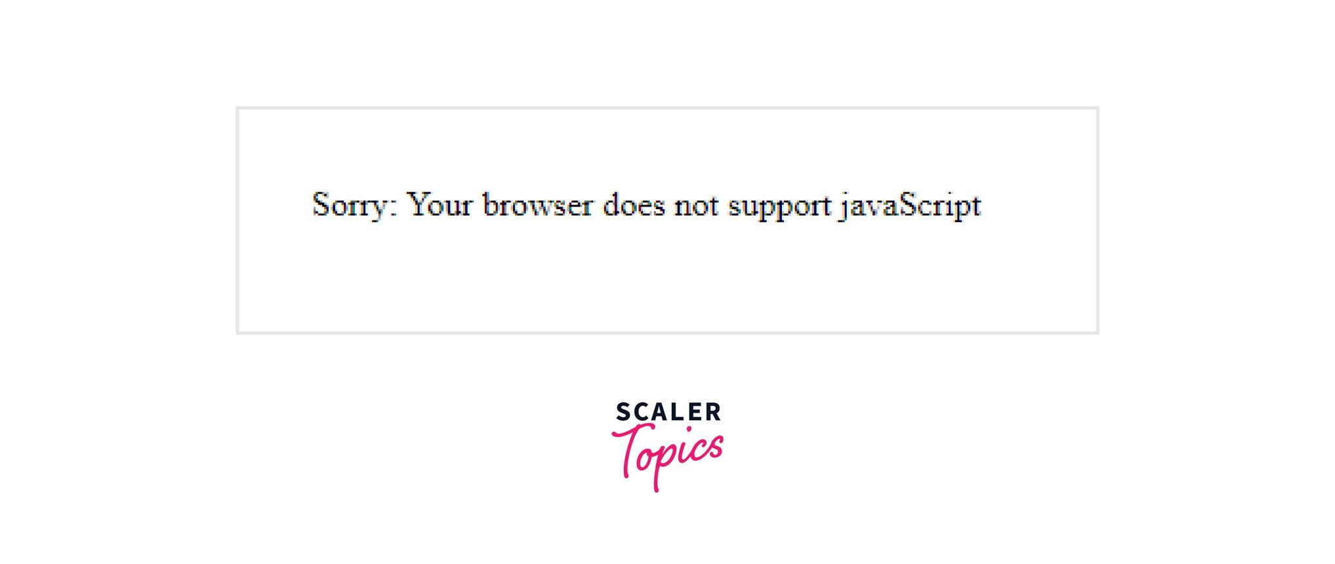
- If JavaScript works → <noscript> content is ignored
- If JavaScript is disabled → <noscript> content appears

🧪 Common Uses of <noscript> (with examples)

🟢 1. Show Warning Message
# Source: AI Source: Provided by: [Data Path: Persons Table -> ID Column: 1, Name_En Column: Motasem Essam] -> From: [ChatGPT] on [5/6/2026]
📖 Description:
Tell users to enable JavaScript.
💻 Full Example:
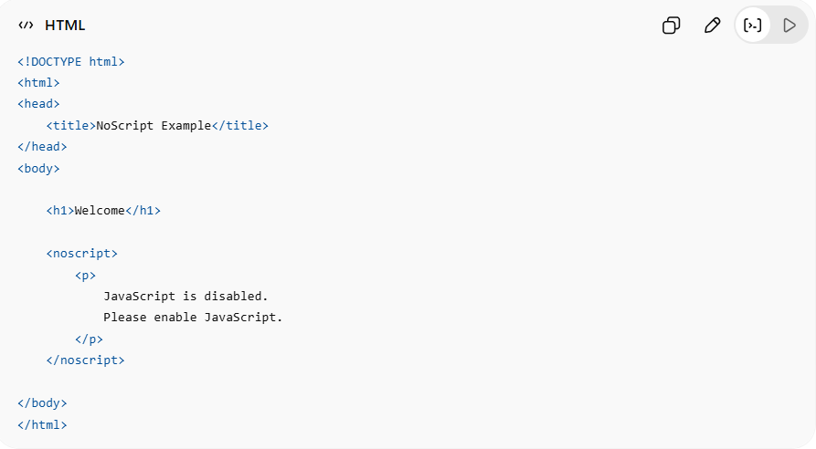
<!DOCTYPE html>
<html>
<head>
<title>NoScript Example</title>
</head>
<body>
<h1>Welcome</h1>
<noscript>
<p>
JavaScript is disabled.
Please enable JavaScript.
</p>
</noscript>
</body>
</html>
👉 Message appears only if JavaScript is disabled

🟡 2. Provide Alternative Content
# Source: AI Source: Provided by: [Data Path: Persons Table -> ID Column: 1, Name_En Column: Motasem Essam] -> From: [ChatGPT] on [5/6/2026]
📖 Description:
Show fallback content when interactive features cannot run.
💻 Full Example:
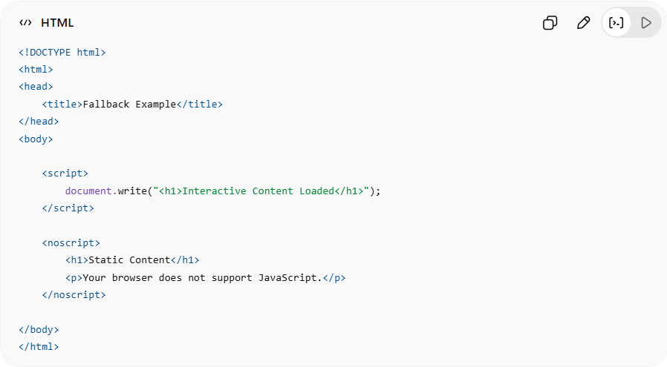
<!DOCTYPE html>
<html>
<head>
<title>Fallback Example</title>
</head>
<body>
<script>
document.write("<h1>Interactive Content Loaded</h1>");
</script>
<noscript>
<h1>Static Content</h1>
<p>Your browser does not support JavaScript.</p>
</noscript>
</body>
</html>
👉 Browser shows fallback content if JS fails

🔵 3. Fallback for Images or Media
# Source: AI Source: Provided by: [Data Path: Persons Table -> ID Column: 1, Name_En Column: Motasem Essam] -> From: [ChatGPT] on [5/6/2026]
📖 Description:
Provide backup media or text.
💻 Full Example:
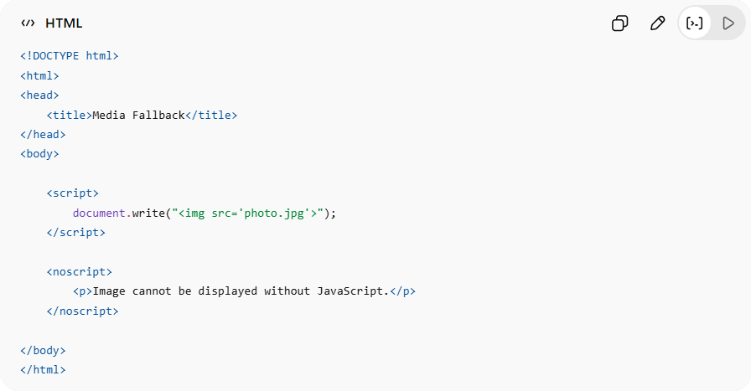
<!DOCTYPE html>
<html>
<head>
<title>Media Fallback</title>
</head>
<body>
<script>
document.write("<img src='photo.jpg'>");
</script>
<noscript>
<p>Image cannot be displayed without JavaScript.</p>
</noscript>
</body>
</html>
👉 Useful when media depends on JavaScript

⚠️ Common Mistakes
# Source: AI Source: Provided by: [Data Path: Persons Table -> ID Column: 1, Name_En Column: Motasem Essam] -> From: [ChatGPT] on [5/6/2026]
❌ Putting Important Content Only in JavaScript
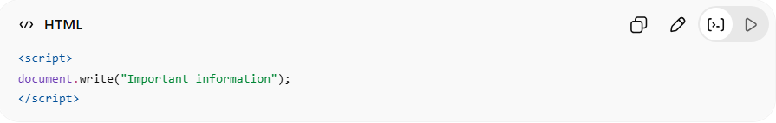
<script>
document.write("Important information");
</script>
👉 Users without JS may see nothing
✅ Better:
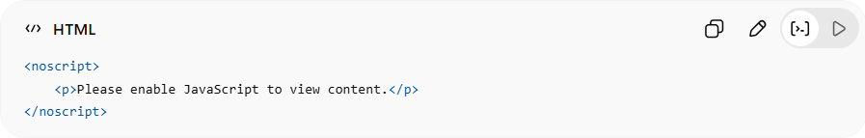
<noscript>
<p>Please enable JavaScript to view content.</p>
</noscript>

⚙️ Key Features
# Source: AI Source: Provided by: [Data Path: Persons Table -> ID Column: 1, Name_En Column: Motasem Essam] -> From: [ChatGPT] on [5/6/2026]
- 🛡️ Provides fallback content
- ⚡ Works when JavaScript is disabled
- 🌐 Improves accessibility
- 👥 Helps users with limited browsers

🚀 In short:
# Source: AI Source: Provided by: [Data Path: Persons Table -> ID Column: 1, Name_En Column: Motasem Essam] -> From: [ChatGPT] on [5/6/2026]
<noscript> = an HTML element that displays alternative content when JavaScript is unavailable or disabled.

